- Atomicity
- Consistency
- Isolation
- Durability
Example:
Isolation: Transactions execute independently of one another. In other words, the partial effects of incomplete transactions should not be visible to other transactions.
Concurrency control is a concept of isolation, which allows multiple transactions to occur at one time without them interfering with each other. In this case, concurrency control fits within the framework of isolation, because it ensures that inconsistencies in the data are not produced because of update and read errors. In the same way we can meet the requirements of isolation by making the transactions occur in a serially (as explained in the example).
In an example, called lost update, we can speak about the case where two people are interacting with the same account:
- Transaction 1: withdrawing $10.00 from an account that has $100.00
- Transaction 2: depositing $100.00 into the same account.
Rationally (serially) the account should contain $190.00 at the end of both transactions. In the case with the lost update; we have a situation in which one transaction stores the update of $200.00; and the other transaction stores the value of $90.00 from the original. The second transaction only applies the change before the first transaction registers it (that means it uses the balance of $100.00 to modify). The first transaction saves the value that it had corresponding to the deduction of $10.00 from $100.00; and the program saves $90 at the end of the complete transaction. This value is not representative of the actual transaction in reality (doesn’t match the expected serial output of $190.00). We can solve this problem, by isolating both transactions by applying each transaction serially (using a lock mechanism). The lock is mechanism doesn’t allow a second transaction to occur concurrently until the most recent transaction has been completed. Once the transaction commits, the second transaction can move forward. These two transactions will only occur one at a time; this will eliminate the inconsistency which has occurred during the two concurrent transactions. In this case, we will not allow transaction 2 to occur without transaction 1 being complete. This mechanism is a type of concurrency controls that demonstrates “Isolation” because it ensured that the transactions are executed independently from one another.

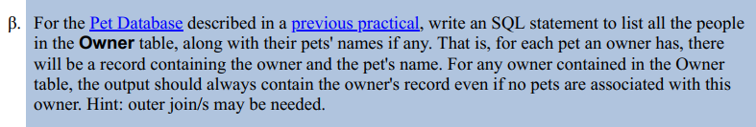

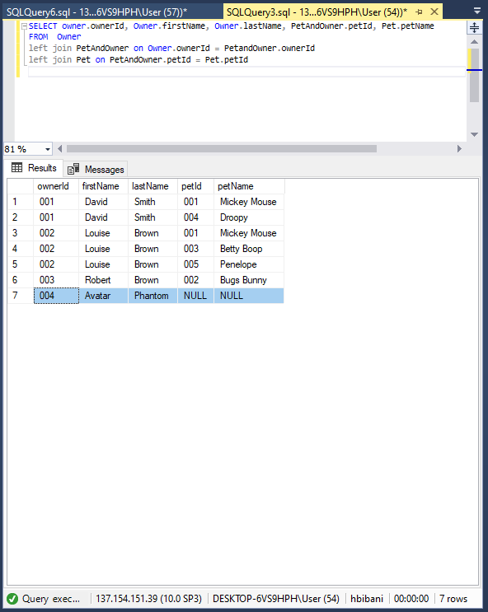

SELECT owner.ownerId, Owner.firstName, Owner.lastName, PetAndOwner.petId, Pet.petName
FROM Owner
left join PetAndOwner on Owner.ownerId = PetandOwner.ownerId
left join Pet on PetAndOwner.petId = Pet.petId

